SZKOŁA PODSTAWOWA NR 8 IM. ORLĄT LWOWSKICH W ZAMOŚCIU

MIĘDZYSZKOLNY KONKURS Z JĘZYKA ANGIELSKIEGO
DLA SZKÓŁ PODSTAWOWYCH
POWIATU ZAMOJSKIEGO
ROK 2010/2011
Termin: 19.02.2011 Godzina: 10.00

Czas: 60min
PART II

Wszystkie odpowiedzi przenieś w odpowiednie miejsca na kartę odpowiedzi

Grammar

Zad 1. Wybierz poprawną odpowiedź i zaznacz odpowiednią literę na karcie odpowiedzi. (max: 20 pkt)

1. | “................................ shall we do?” - “Let’s go and tell the police.”
1. | A) When B) Why C) How D) What
2. | How much ..............these books cost?
2. | A) do B) does C) are D) have
3. | I more often go to work ..... than .....
3. | A) by foot ... by car B) on foot ... with the car C) by foot ... in a car D) on foot ... by car
4. | Do you ..... to the cinema?
4. | A) like to going B) like going C) fancy to go D) want me going
5. | Brad Pitt ………………. a great actor.
5. | A) is’nt B) has C) are D) is
6. | There is ..... here. ..... has left.
6. | A) anybody ... All B) all ... Nobody C) none ... Everybody D) nobody ... Everyone
7. | “:..... car is parked in front of our house” “Mark and Stephanie’s”
7. | A) Whose B) Who C) What D) Which
8. | The car you bought in ... United Kingdom is one of ... most expensive I've ever seen.
8. | A) the ... the B) - ... the C) a ... the D) - ... -
9. | Where ..... you ...... ?
9. | A) did ... born B) have ... born C) were ... born D) do ... bear
10. | Paul has ..... done his homework so now he can play football with friends.
10. | A) always B) still C) already D) yet
11. | I never do my homework ..... night. I do it ..... the morning.
11. | A) at ... in B) in ... in C) on ... on D) in ... at
12. | I have ..... money but it is ..... to buy a new house.
12. | A) a few ... much B) little ... a lot C) much ... too few D) some ... not enough
13. | Mike is ..... than Paul but Paul is ...... boy in school.
13. | A) shorter ... most interesting B) uglier ... more funnier  C) the better ... the best D) more handsome .. the most intelligent
14. | Excuse me, but the umbrella you've just taken is .....
14. | A) my B) me C) mine D) our
15. | Do we have ..... eggs? Yes, there are ..... in the fridge.
15. | A) some ... few B) any ... some C) the ... much D) a little ... a lot
16. | Somebody ..... a very nice letter to me.
16. | A) writed B) wrote C) write D) written
17. | .... you ever .... China?
17. | A) Did ... visit B) Did ... come to C) Have ... been to D) Were ... in
18. | I am very busy now, because I ..... to the exam.
18. | A) am preparing B) prepare C) will prepare D) prepared
19. | ..... are a lot of nice restaurants here in Cracow.
19. | A) These B) That C) Those D) There
20. | ..... you see any interesting movies last week?
20. | A) Do B) Did C) Have D) Does

Prepared by Justyna Babiarz-Furmanek

Vocabulary

Zad 2. Wybierz poprawną odpowiedź i zaznacz odpowiednią literę na karcie odpowiedzi. (max: 10 pkt)

1. | Professor Epstein .................a lot of prizes for his time machine.
1. | A) found B) gave C) dropped D) won
2. | A/An ...........wears a uniform. You call this person if someone robs you.
2. | A) carpenter B) journalist C) police officer D) postal worker
3. | After you wash your hands you ...................................them with a towel.
3. | A) wave B) shake C) dry D) clap
4 | ........................is a subject where you learn about the elements that make up the Earth, universe and living things.
4 | A) History B) Chemistry C) Information Technology D) Physical Education
5. | A ……….is a small animal which moves very slowly and carries its house on its back.
5. | A) snail B) lamb C) hedgehog D) gosling
6. | ....................is a coat of hair on the body of an animal.
6. | A) Fur B) A whisker C) A paw D) A feather
7. | …is the flat land between two mountains and which has a river flowing through it.
7. | A) sea B) volcano C) valley D) cave
8. | He can’t hear. He’s .........................
8. | A) death B) weak C) deaf D) blind
9. | Harrods is a very large and famous ...................................in London and it’s known for selling all kinds of expensive and unusual things.
9. | A)travel agency B) department store C) book shop D) supermarket
10. | There are two ………………………………..in the living room.
10. | A) kettles B) dishwashers C) cushions D) taps

Prepared by Justyna Babiarz - Furmanek

Zad 3. Przeczytaj tekst. Popatrz na obrazki. W każdą lukę wstaw jeden brakujący wyraz. Następnie odpowiedz na podkreślone pytanie pod tekstem wybierając poprawną odpowiedź w kratce. (max: 10 pkt) KARTA ODPOWIEDZI
When Peter woke up on Sunday morning, he looked out of the window. It was dark and 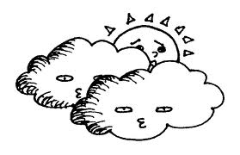…CLOUDY… and there was heavy  1.……….…... “Oh no!” he thought. “Another boring Sunday at home!” He got 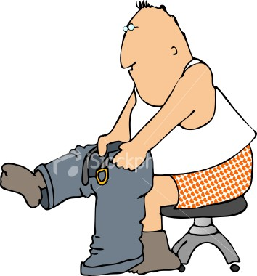 2.………………….. and slowly went downstairs to have breakfast with his parents but they weren’t in the kitchen. Peter found them in the 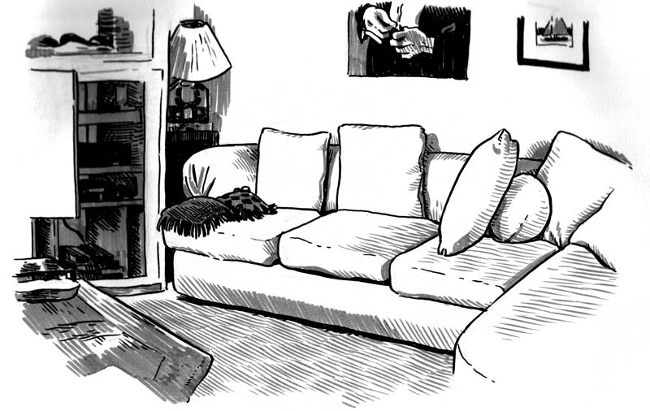3…………………….. They were sitting on the floor in front of the 4……………………….. reading their Sunday 5………………………………. There was a picnic 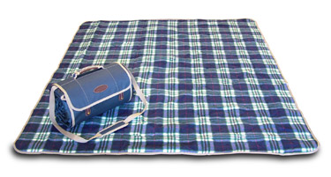6………………………… with sandwiches, cakes and fruit in front of them. “Come and sit with us Peter,” they said. When Peter 7………………………….. down, he saw a new computer game on the floor next to him. “It’s a present for a rainy day!” said his Mum. Peter was very happy! “Thank you!” he said and quickly 8………………………… to his room to play. “My Sundays won’t be boring anymore!” he 9……………………… and smiled.

10. What’s the best name for this story? Tick ( √ ) one box.

A birthday present

A rainy day

A boring picnic

Taken from Skills Builder Flyers (Prepared by Justyna Babiarz-Furmanek)

Reading

Zad 4. Przeczytaj tekst. Wybierz właściwy wyraz i wpisz w puste miejsca według przykładu. (max: 10 pkt) KARTA ODPOWIEDZI
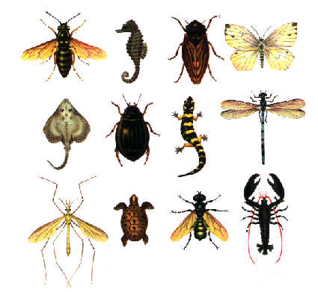
INSECTS

Example: You can find insects .........everywhere .........
1. They live in forests, fields and.................................rivers. insects are usually
- very small and they only live .................................a few days or weeks.
- They......................plants and other, smaller insects.
- Insects can be different colours. Most ...................................black but
- ................................can also be green, silver, red or purple. It is difficult being
- an insect. Hungry bats, frogs and fish eat hundreds of ………………………
- every day! Spiders also ………………….insects because that’s the only
- food they like. Most people don’t like insects …………………..they think
- they are dirty and horrible. I’m not afraid ……………….insects! I think
- they’re very interesting to watch and I know they ……………..hurt people.
Example everything everywhere somewhere
1. into near next
2. at in for
3. ate eat eating
4. is be are
5. it they he
6. them their which
7. caught catch catching
8. than because but
9. to of from
10. didn’t do don’t

Taken from Skills Builder Flyers 2 (Prepared by Justyna Babiarz-Furmanek)

Zad. 5. Przeczytaj uważnie podany tekst a następnie zaznacz czy zdania poniżej są prawdziwe (True) fałszywe czy (False).(max:10 pkt) KARTA ODPOWIEDZI

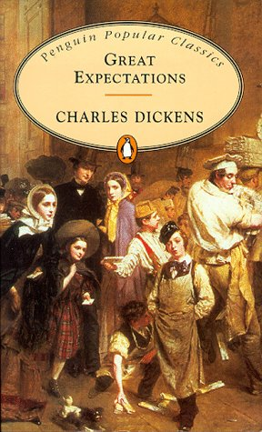 GREAT EXPECTATIONS by Charles Dickens
About the author:
Charles Dickens (1812 – 1870) is one of England’s most famous novelists. His stories take place in Victorian England. He wrote many books, including David Copperfield and Oliver Twist.

About the story:
Pip is an orphan (1). He lives with his sister, who is married to Joe Gargery, a kind blacksmith (2), in a village in the south of England. One day Pip helps a convict (3) who has escaped (4) from a prison (5) ship. Pip gives him food.
When he is older, Pip goes to play at the house of a rich woman, Miss Havisham, who has a beautiful adopted daughter called Estella. Miss Havisham is a strange woman. Her fiancé (6) didn’t arrive on her wedding (7) day, and since then she has kept her wedding cake and wears only her wedding dress. Pip likes Estella but he thinks she isn’t interested in him because he is poor and has no education. Pip works as a blacksmith in Joe Gargery’s forge (8) but he hates the job and wants more from life – and he wants Estella. Then one day a stranger arrives …

This extract comes from the part of the book where Pip meets Mr Jaggers for the first time.
It was a Saturday night. We were sitting round the fire at the village inn (9). Then a strange gentleman came up to us and said:
“I believe there may be a blacksmith here called Joe Gargery.”
“That is me,” said Joe.
“You have a young man with you called Pip,” said the stranger. “Is he here?”
“I am here,” I said.
“I would like to talk to you two in private,” he said.
In silence, we three walked home.
“My name’s Jaggers,” he said, “and I am a lawyer (10) in London. I must tell you that Pip has Great Expectations. Soon he will inherit (11) a lot of money from an anonymous person. This person wants Pip to leave this place and have a gentleman’s education in London.”
I could not believe my ears. My dream was coming true.
“I have some money with me for your education and expanses. When will you come to London?”
I said I could come immediately.
“Good. First,” said Mr Jaggers, “you need some new clothes. I’ll leave you twenty pounds. I think it will be good if you leave for London as soon as possible.”
When he left us, Joe locked the front door and we sat by the fire. We didn’t speak for a long time. Then Joe got up and held me warmly and said he was pleased for me, but I knew he was very sad.
I left out village at five the next morning. I told Joe that I would prefer to walk away alone. I had a quick breakfast. I kissed my sister and hugged Joe. Then I picked up my bag and left.
I walked fast and whistled. The village was quiet. I remembered my days as a child there. The future was unknown and I began to cry. At the end of the village I put my hand on the village signpost and said, “Goodbye, my dear, dear friend!”

- Charles Dickens wrote about life in England in Victorian times. …… ….
- Joe Gargery is Pip’s father. … ….
- Pip was once kind to an escaped convict. …… …
- Miss Havisham is Estella’s aunt. …… ……
- Miss Havisham is single. …… ….
- Estella isn’t interested in Pip …… …..
- Pip enjoys his job as a blacksmith ……… …..
- Pip doesn’t like his life in the village…… ……
- Joe Gargery doesn’t want to talk to Pip because he is angry with him…… …..
- Pip goes to London with Mr Jaggers. … ……

Glossary:

(1) an orphan – a child that has no parents | (2) a blacksmith 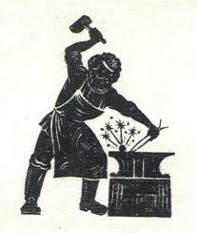 | (3) a convict – a criminal | (4) to escape – to run away
( 5) prison  | (6) fiancé – a woman who is going to be married | (7) wedding  | (8) a forge – 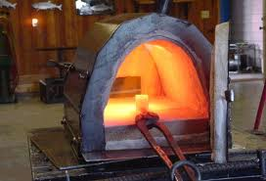
(9) inn – a small hotel | (10) a lawyer 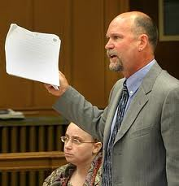 | (11) to inherit – to get money, a house or other things from somebody who has died

Adapted from Sky 3(Prepared by Justyna Babiarz-Furmanek)

Communication

Zad. 6. Ponumeruj zdania w odpowiedniej kolejności tak aby utworzyć rozmowę
(max: 7 pkt) KARTA ODPOWIEDZI
- It’s Ł11. 99.
- Sure. Here you are.
- Excuse me. How much is that scarf?
- Thanks.
- Which one?
- Ok. Can I have it, please?
- The blue and green one.

1………. 2……… 3………. 4……….. 5……….. 6……….. 7…………

YOUNG CHAMPIONS OF ENGLISH GRAMMAR – ANSWERS
ZAD 1.
 | 1. | 2. | 3. | 4. | 5. | 6. | 7. | 8. | 9. | 10. | 11. | 12. | 13. | 14. | 15. | 16. | 17. | 18. | 19. | 20
 | D | A | D | B | D | D | A | A | C | C | A | D | D | C | B | B | C | A | D | B

ZAD 2.
1. | 2. | 3. | 4. | 5. | 6. | 7. | 8. | 9. | 10.
D | C | C | B | A | A | C | C | B | C
ZAD 3.
1. | 2. | 3. | 4. | 5. | 6. | 7. | 8. | 9. | 10.
rain | dressed | Living room/  Sitting room | Fire/  Fireplace/  hearth | Papers/  newspapers | blanket | sat | ran | thought | A rainy day

ZAD 4.
1. | 2. | 3. | 4. | 5. | 6. | 7. | 8. | 9. | 10.
near | for | eat | are | they | them | catch | because | of | Don’t

ZAD 5.
1. | 2. | 3. | 4. | 5. | 6. | 7. | 8. | 9. | 10.
T | F | T | F | T | F | F | T | F | F

ZAD 6.
1. | 2. | 3. | 4. | 5. | 6. | 7.
c | e | g | a | f | b | d

